|  |  |
| --- | --- |
| **2d car game**  Using pygame | ***Abstract***  This car game is our first python project and was a fun way to learn Python and get experience with Pygame. The game is reminiscent of most 2d car game  ***MEMBERS***   1. MUHAMMAD SAMI 2. ARHAM ZAHID 3. MAAZ AHMED 4. SYED ARMAGHAN HASHMI 5. MOHAMMAD |

**SCOPE:**

PyGame is a good set of libraries for game development. Also python as a language is very comfortable in writing games especially for beginners. Also the object oriented approach is very handy in game development.

But remember, pygame is not the best and there are way better GameEngines.

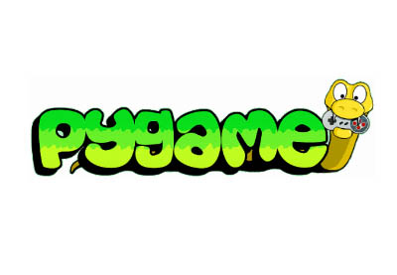

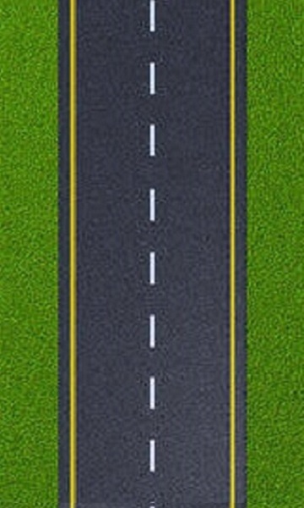**PURPOSE:**

welcomes all Python game, art, music

, sound, video and multimedia projects.

 Once you have finished getting started

you could add a new project or learn

 about pygame by reading the docs

**ADVANTAGES:**

1. Comes with many Operating systems
2. Truly portable
3. It's Simple and easy to use

**DEMO PICTURES:**

**  **

**Step involves in project:**

|  |
| --- |
|  |
| 1 | (DISPLAYING AND REFRESHING BG ROLE) |
|  |  |
|  |  |
| 2 | (THE DEF GAMELOOP FUNCTIONING OF RUNNING THE GAME) |
|  |  |
|  |  |
| 3 | (FUNCTIONING OF CARS,ENEMY,ROAD ETC) |
|  |  |
|  |  |
| 4 | (FUNCTIONING OF IMAGE SOUND AND CO-RELATION WITH THE GAME) |
|  |  |
|  |  |
| 5 | (THE FUNCTION AND THE LOGIC FOR THE MENU OF THE GAME) |

**From where we learn pygame:**

<https://www.youtube.com/watch?v=cJbnWZGX-XY&feature=youtu.be>